


Module Code & Module Title
CC6057NI Applied Machine Learning

75%Individual Coursework
Submission: Milestone 1
Academic Semester: Autumn Semester 2025
Credit: 15 credit semester long module

Student Name: Prashant Rijal
London Met ID: 23048683
College ID: np01ai4a230142
Assignment Due Date: 15/12/2025.
Assignment Submission Date: 15/12/2025
Submitted To: Mr. Alish KC

GitHub Link | https://github.com/Prashant-Rijal-dev/SMS_Spam_Detection

I confirm that I understand my coursework needs to be submitted online via MST Classroom under the relevant module page before the deadline for my assignment to be accepted and marked. I am fully aware that late submissions will be treated as non-submission and a mark of zero will be awarded.

Introduction
This project aims to design and develop a machine learning application which is capable of classifying SMS messages as either malicious messages (Spam) or real/legit messages (Ham), due to the growth of mobile communication SMS has become one of the primary targets for phishing attacks and unprompted marketing. This project aims to filter these types of messages in order to make user experience secure and solicit.
The project uses Supervised Machine Learning in which the model learns to map input data(Features) to output labels(Target Variable) based on the labelled dataset. For the project following concepts will be utilized:
- Natural Language Processing (NLP):
  - It is the field of AI focused on helping computers understand human language.
  - The use of NLP in this project is to clean the data (raw text) and convert it to numerical format for the computer to understand.
- Vectorization:
  - It is the process of converting non numerical data into numerical vectors for processing.
  - For the project TF-IDF (Term Frequency-Inverse Document Frequency) will be used to transform text into numerical vectors.
  - TF-IDF‘s main concept is to assign weight based on their importance.
- Classification Algorithm:
  - They are tools in ML which sorts data into categories or classes.
  - The project uses 3 distinct types of learning algorithms for classification model:
    - Naïve Bayes (Probabilistic)
    - Logistic Regression (Linear)
    - KNN K-Nearest Neighbour (Instance based)

Problem Domain
The SMS Spam Detection is a type of binary classification problem. The input is a string of text or sentences (SMS message) and the output is a binary label in our case we assign “0 for Ham” and “1 for Spam”. The unstructured structure of the SMS data is a challenge as it contains less characters more often than not messages containing abbreviation, slangs, and misspelling with the addition of lack of metadata.
Dataset Description
Dataset used: UCI SMS Spam Collection
The project utilizes the UCI SMS Spam Collection which is a public dataset sourced from University of California, Irvine’s (UCI) Machine Learning Repository.
Here are some facts that we can get from the dataset:
- Type: .txt (the original dataset is in txt file format)
- No of rows of data: 5572
- Data Type: Unstructured English data (object)
- Class Imbalance: Heavily Imbalanced
  - Ham=4824 (86.591276%) ,
  - Spam=747 (13.408724%)
- Implications: Due to the heavy class imbalance the model may have less accuracy so Precision and Recall metrices will be more important than accuracy during the evaluation of the model.
Societal or Business Relevance
- Cybersecurity: SMS phishing is a major threat in current time as it is used to steal banking details or other private information, this classifier is like the first line of defence against these types of threats.
- Business Integrity: Even now almost all top businesses and companies such as X, Meta etc rely on SMS for one time OTP but if due to constant spam email threats users stop trusting or using SMS it compromises security.
- User friendly: the spam filters automatically filters spam SMS saving time for the user and also decluttering mobile storage.
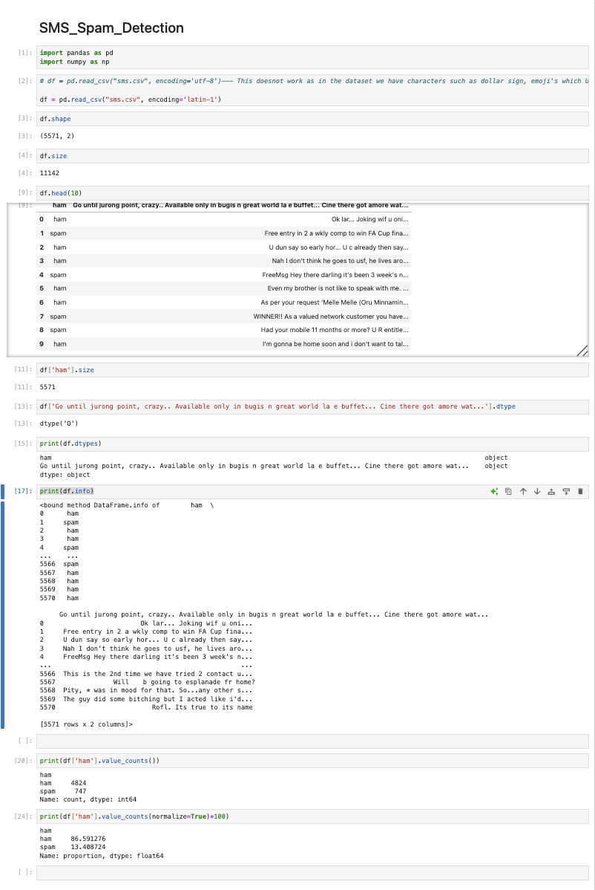

Solution

